Project Proposal for Tier 0/Tier 1 HPC Access
Period
Give the granting period you apply for (month year - month year)
Project title
Title as given in the online proposal
Type of project
Either “new project” or “project extension”
HPC system(s) and corresponding centre(s)
Please name the HPC system(s)/module(s) for which you are applying
Project ID or project acronym
Please provide in case of a project extension
Principal investigator
Name, affiliation, contact data
Project contributor(s)
Name, affiliation, contact data

The length of the project description is restricted to 18 pages (font 11 pt)!
Contents
1 Introduction 3
2 Preliminary Work 3
3 Description of the Project 3
3.1 Project Details 3
3.1.1 Sub-project 1 3
3.1.2 Sub-project 2 3
3.2 Review Processes 4
4 Numerical Methods and Algorithms 4
5 Computer Resources 4
5.1 Code performance and workflow 4
5.2 Justification of number of core hours requested 6
6 Resource Management and Work Schedule 6
6.1 Resource management 6
6.2 Work schedule 6
6.2.1 Sub-project 1 7
6.2.2 Sub-project 2 7
7 Key Personnel and Experiences 7
8 Bibliographic References 8

Introduction
Give a short outline of the scientific background of your research, including references.
(about 0.5 to 1 page)

Preliminary Work
Provide a brief summary of your preliminary work in connection with the proposed project, including references.
(about 1 to 2 pages)

Description of the Project

Project Details
Describe your research project in detail, structured in sub-projects, if applicable. Include discussion of the scientific questions that you are planning to address and the overall scientific goals of the project. It is important that you describe the innovative aspects, impact and topicality of the proposal.
- Scientific questions you want to address
- Scientific objectives
- Computational objectives
- Approach and expected outcome
- Expected impact on the research area
- Scientific and technical innovation potential
- Progress beyond the state-of-the-art

Sub-project 1

Sub-project 2
...
(1 to 2 pages per sub-project)

Review Processes
Has the underlying research project already successfully undergone a scientific review process? Is the project funded by public money? If yes, please also provide information about the funding source (e.g. State, BMWi, BMBF, DFG, EU,$…$) and the funding time frame. If possible, please provide the corresponding review report and upload it as supplemental material.

Numerical Methods and Algorithms
Describe the numerical methods and algorithms that you are planning to use, improve, or develop.
(1 to 2 pages)

Computer Resources

Code performance and workflow
Describe all codes, packages or libraries that you need to undertake the project, and how these will enable the research to be achieved. Include for each code to be used information about
- Which code will be used
- On which hardware the code will be used (CPUs, GPUs, etc. or combinations, if
- applicable)
- How is the code parallelized (pure MPI, mixed MPI/OpenMP, Pthreads, CUDA, etc.)
- The amount of memory necessary (per core, per node and in total)
- Scaling plots and tables with speedup results for runs with typical, parameter sets, problem size, and I/O of the planned project (no general benchmark results are accepted). Scaling data should start with the lowest number of cores possible.
- Describe architecture, machine/system name, and problem size used for the scaling plots
- Current job profile (independent jobs, chained jobs, workflow, etc.)
- Describe memory requirements, requirements concerning the High Performance network and I/O requirements
Important: please consider the corresponding technical guidelines and requirements (e.g. required minimal code scalability, memory restrictions, etc.) of the machine you have chosen!
If you use third-party codes, include
- Name, version, licensing model and conditions
- Web page and other references
- Contact information of the code developers.
- Your relationship to the code (developer, collaborator to main developers, end user, etc.)
Here we give an example table and plot for presenting scaling and performance information. The presented scaling should range from a single core to the maximal possible number of cores. If this is not doable, the presented scaling should range from the lowest possible number to the maximal possible number of cores for your case. Please replace the text in <Courier> by the appropriate information.
Table 1: Scaling behavior of <LINPACK> on <Hawk, JUWELS, SuperMUC-NG> at <HLRS, JSC, LRZ>. This test was performed with 5⋅10⁶ particles, absolute timings per time step (s) and relative speedup normalized to 1 core are given.
#cores | absolute timing (s) | speedup | Performance per core [MFLOP/s]
1 | 3781.2 | 1.0 | 800
2 | 1890.6 | 2.0 | 800
4 | 945.3 | 4.0 | 800
8 | 472.7 | 8.0 | 800
16 | 236.3 | 16.0 | 800
32 | 118.1 | 32.0 | 800
64 | 59.1 | 64.0 | 800
128 | 32.8 | 115.2 | 720
256 | 18.4 | 204.8 | 640
512 | 10.5 | 358.4 | 559
1024 | 6.2 | 614.4 | 480
2048 | 3.7 | 1024.0 | 400
4096 | 2.3 | 1638.4 | 320

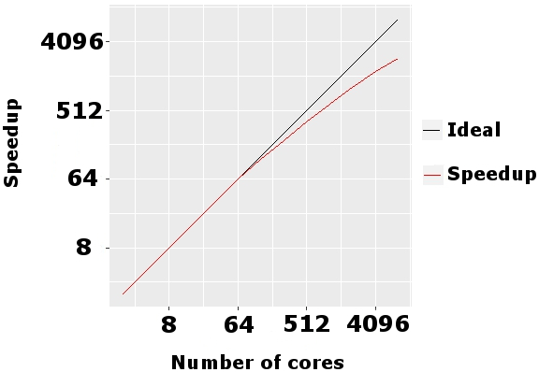
Figure 1: Scaling behavior of code on architecture and system at location. This data was obtained with a problem size of size.
(1 to 2 pages)

Justification of number of core hours requested
Outline the amount of resources you request for the current granting period, structured in sub-projects, if applicable.
If you are requesting different types of resources (e.g. CPUs, GPUs, etc.), please provide the following information and table for each type of resource separately and use the unit core hours (core-h). For GPUs please specify the resources in terms of core hours of the corresponding host CPUs. If you request resources on several HPC systems or modules, please justify why this is necessary for your project.
- Type of run (e.g. pre- /post-processing run, production run, visualization, etc.)
- Problem size for planned runs (e.g. # particles or the like)
- Number of runs planned
- Number of steps per run
- Wall-clock time per run
- Number of cores used per run (for GPUs: number of cores of the host CPUs)
- Total amount of requested computing time in core-h
- Resources for data analytics, if applicable

Table 2: The following CPU resources are requested
Sub-project | Type  of run | Problem  size | # runs |  | # steps/  run | Wall time/  step [hours] |  | #cores/  run | Total  [core-h]
Sub-proj. 1 | Preproc | P1 |  | R1 | S1 | W1 | C1 |  | R1$⋅$S1$⋅$W1$⋅$C1
 | Type 1 | P2 |  | R2 | S2 | W2 | C2 |  | R2$⋅$S2$⋅$W2$⋅$C2
$$⋯$$ | $$⋯$$
TOTAL |  |  |  |  |  |  |  |  | sum of above

Table 3: The following GPU resources are requested
Sub-project | Type  of run | Problem  size | # runs |  | # steps/  run | Wall time/  step [hours] |  | #host cores/  run | Total  [core-h]
Sub-proj. 1 | Preproc | P1 |  | R1 | S1 | W1 | C1 |  | R1$⋅$S1$⋅$W1$⋅$C1
 | Type 1 | P2 |  | R2 | S2 | W2 | C2 |  | R2$⋅$S2$⋅$W2$⋅$C2
$$⋯$$ | $$⋯$$
TOTAL |  |  |  |  |  |  |  |  | sum of above

(0.5 to 1 page)

Resource Management and Work Schedule

Resource management
Describe how you intend to manage the resources you have requested. This should include a description of the methods you will deploy to monitor progress of the project and how project results are documented.
(0.5 to 1 page)

Work schedule
Provide tables and Gantt charts for a clear presentation of the work schedule, structured in sub-projects, if applicable.

Sub-project 1
...

Sub-project 2
...
Example for a Gantt chart:
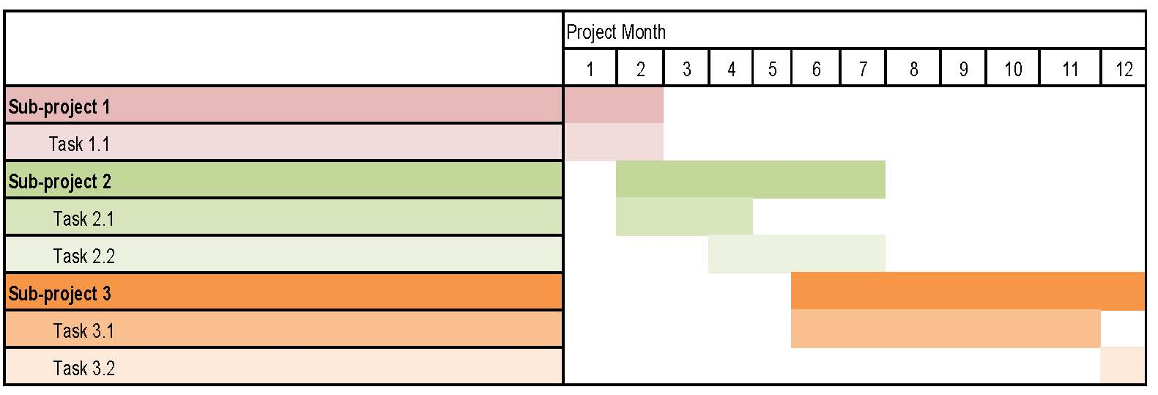
Figure 2: Work schedule for the project.

Key Personnel and Experiences
Give a short introduction of the key persons involved in the project and their experience (max 3 persons).
(half a page)

Bibliographic References
Provide recent/most important bibliographic references that are relevant to the project.

